Hasil skor *docking* molekuler 10 konformasi Ligan terhadap Enzim siklooksigenase-2.

|  |  |  |  |  |  |  |  |  |  |  |  |  |  |  |  |
| --- | --- | --- | --- | --- | --- | --- | --- | --- | --- | --- | --- | --- | --- | --- | --- |
| **Rata-rata** | | -76.37 | -76.86 | -79,79 | 76.60 | -76.42 | -75.05 | -75.74 | -73.06 | -68.94 | -63.30 | -75.12 | -63.68 | -63.08 | -67.70 |
| **Konformasi** | **10** | -75.23 | -77.75 | -80.18 | -71.92 | -77.83 | -76.71 | -75.32 | -68.96 | -65.58 | -62.62 | -63.75 | -64.06 | -61.14 | -59.19 |
| **9** | -75.28 | -78.05 | -79.99 | -73.59 | -75.99 | -74.46 | -75.32 | -69.58 | -66.18 | -67.20 | -75.32 | -64.34 | -61.91 | -60.81 |
| **8** | -76.04 | -77.86 | -80.61 | -79.21 | -76.25 | -72.92 | -75.46 | -75.92 | -73.02 | -65.32 | -75.72 | -62.89 | 61.48 | -70.53 |
| **7** | -74.78 | -70.77 | -79.90 | -79.50 | -76.38 | -75.46 | -75.19 | -76.03 | -70.18 | -64.41 | -76.63 | -52.96 | -62.98 | -69.98 |
| **6** | -78.47 | -77.90 | -80.55 | -79.64 | -76.40 | -75.52 | -75.77 | -74.52 | -71.05 | -62.10 | -76.51 | -65.53 | -62.79 | -70.89 |
| **5** | -77.33 | -77.50 | -79.14 | -79.62 | -76.31 | -75.89 | -75.98 | -74.21 | -69.84 | -62.11 | -77.67 | -66.25 | -63.86 | -70.20 |
| **4** | -75.64 | -77.15 | -79.15 | -73.23 | -76.22 | -74.74 | -76.30 | -73.77 | -68.22 | -62.00 | -75.99 | -64.90 | -64.52 | -68.72 |
| **3** | -75.86 | -77.20 | -79.15 | -73.12 | -76.40 | -76.11 | -75.84 | -72.68 | -67.74 | -62.55 | -76.90 | -65.67 | -63.26 | -68.93 |
| **2** | -77.85 | -77.26 | -79.78 | -73.01 | -76.22 | -74.76 | -76.33 | -72.06 | -68.62 | -62.57 | -75.80 | -65.41 | -64.72 | -67.87 |
| **1** | -77.22 | -77.17 | -79.47 | -73.17 | -76.24 | -73.93 | -75.93 | -72.95 | -69.00 | -62.19 | -76.92 | -64.83 | -64.19 | -68.93 |
| **Ligan** | | Native ligan (IMN) | Ibuprofen | Pilloin | Cirsimaritin | Trimethylapigenin | Tetramethylluteolin | Ladanein | Eupatoin | Salvigenin | 6-hidroksi-5,7,3’,’4-Tetrametoksiflavone | 3’,5,6,7-Tetramethoxy-4’-hydroxy-8-C-prenylflavon | tettramethylacutellarein | Sinensetin | 6-hidroksi-5,7,3-Trimetoksiflavon |

Hasil Pencarian Binding Site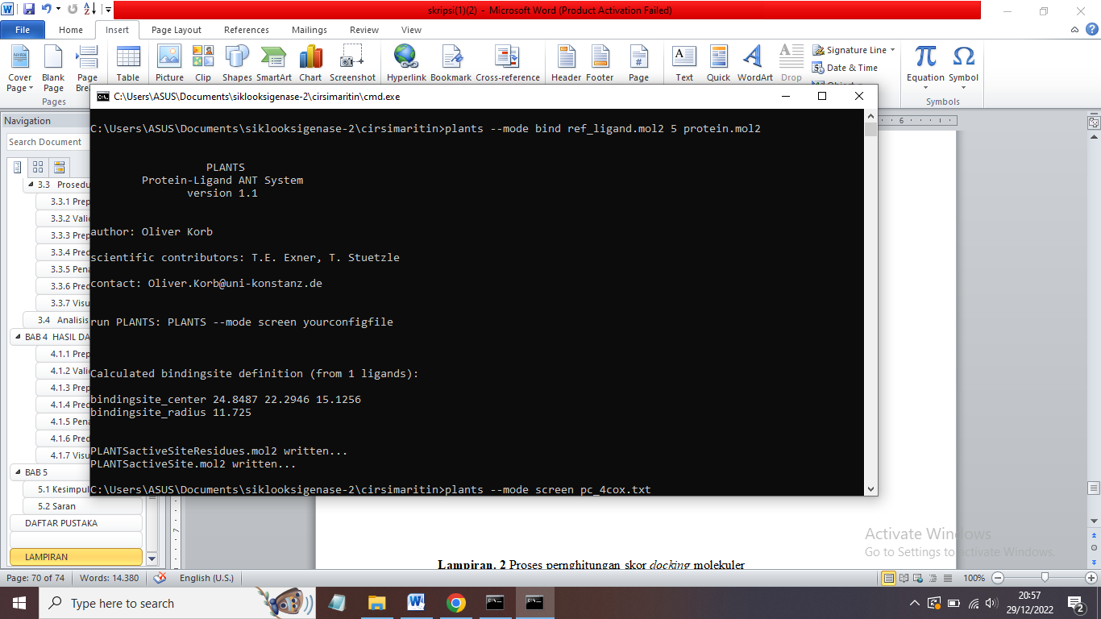

Nilai RMSD Hasil Validasi metode *Docking* Molekuler

