### International Journal of Management, Business, and Social Sciences

Vol. 1, No. 1, 2022, pp. …-…

Published by Department of Management, Faculty of Economics,

Universitas Wahid Hasyim

(e-ISSN: [2962-5971](https://publikasiilmiah.unwahas.ac.id/index.php/IJMBS) ; p-ISSN: [2963-8410](https://publikasiilmiah.unwahas.ac.id/index.php/IJMBS))

DOI: https://doi.org/[10.31942/ijmbs.v1i1.6791](https://publikasiilmiah.unwahas.ac.id/index.php/IJMBS/)

|  |  |
| --- | --- |
| **UTILIZATION OF THE COMMON SIZE METHOD IN ANALYZING POPULATION DATA MANAGEMENT**  **Turini1, Safitri Akbari2, Suwandi3, Mohammad Umar Fakhrudin4, Willy Eka Septian5**  1,2,3,4,5 Catur Insan Cendekia University.  [turini@cic.ac.id](mailto:turini@cic.ac.id), [safitri.akbari@ac.id](mailto:safitri.akbari@ac.id), [suwandi@cic.ac.id](mailto:suwandi@cic.ac.id), [mohammad.fakhrudin@cic.ac.id](mailto:mohammad.fakhrudin@cic.ac.id), [willy.eka.septian@cic.ac.id](mailto:willy.eka.septian@cic.ac.id) | |
| Keywords :  *Utilization; common size; analyzing; populati*on, | **Abstract**  The purpose of this research was to (1) collect data on the total population in Singkup Village, (2) recapitulate population data based on, (a) Gender, (b) Education, (c) Type of Occupation, (d) marital status, (e ) Age, (3) submit a report on the results of recording Village population data to the Head of Singkup Village, Pasawahan District and hold discussions about the follow-up of the results of this research. The method that the writer uses in this research is descriptive qualitative research. The data collection methods used were observation and interviews. The data were processed using the Microsoft Excel application with the common size method. The results of this study indicate that the population in Singkup Village, Pasawahan District - Kuningan Regency is 1,848 people. The male population is 954 people (52%), and women are 894 people (48%). The types of work for the residents of Singkup Village include: farmers, private employees, Soldiers, Civil Servants, Domestic Servants. Businessman. The limitation of this study is that there are no graphs made from the results of processing population data in Singkup Village. The contribution resulting from this research is to broaden the insights and knowledge of students and lecturers in analyzing population data processing using the common size method. The novelty of this study is that the researchers held discussions with the Village Head about what the Village Head would do in responding to residents who did not have permanent jobs. |

**INTRODUCTION**

Population data is any display of population data in official or unofficial form issued by population registration bodies (government or non-government), in various forms, including numbers, graphics, pictures and others (Ramadhan & Setyowati, 2023). Population data is individual data or structured aggregate data as a result of population registration and civil registration activities (Prasetyana et al., 2024). Population data collected from population registration and civil registration becomes population aggregate data which includes individual data sets in the form of quantitative data and qualitative data (Hidayatullah et al., 2024). The benefits of population data : (1)Public services, include the issuance of driving licenses, business licenses, taxpayer services, banking services, land certificate issuance services, insurance, public health insurance, and social security for workers, (2)Development planning namely for national development planning, education planning, health planning, workforce planning, and people's poverty alleviation, (3)Budget allocation includes determining the General Allocation Fund and calculating potential taxation, (4)Democracy development, namely the preparation of Population Aggregate Data per sub-district and the preparation of Potential Voter Population Data, (5)Law enforcement and crime prevention are among others to facilitate the tracking of criminals, preventing trafficking in persons and preventing the sending of illegal workers (Rohman & Effindi, 2022).

In line with the development of the population database, it is also necessary to clarify regarding the regulation of access rights to the use of population data both for officers at the organizers, implementing agencies, and users of population data (Pujiyanto & Alamsyah, 2022). Thus it is necessary to apply criminal sanctions to each resident so that there is no longer discrimination among residents, it is necessary to adjust the amount of criminal sanctions for residents of Indonesian Citizens and residents of Foreign Citizens.

With the establishment of a valid population database, it can be used as data/material/input for the development of a district population database, as well as a basis for granting NIK to each resident, to support orderly population administration, orderly administration of public services, holding elections and for holding elections for regional heads and in the long term it is used as basic data in the framework of the National Population Database Development (Maria et al., 2023).

Singkup Village is one of the villages in Pasawahan District, Kuningan Regency. Singkup Village is one of the villages assisted by lecturers and students at the University of Catur Insan Cendekia - Cirebon City. One of the studies conducted by Catur Insan Cendekia University students in this village is about managing data on Singkup Village residents.

The purpose of this research was to (1) collect data on the total population in Singkup Village, (2) recapitulate population data based on, (a) Gender, (b) Education, (c) Type of Occupation, (d) marital status, (e ) Age, (3) submit a report on the results of recording Village population data to the Head of Singkup Village, Pasawahan District and hold discussions about the follow-up of the results of this research.

**LITERATURE REVIEW**

**Population Data**

Population data refers to information collected and aggregated about the population of a region, which includes various characteristics of the population such as number, age, gender, education level, marital status, employment, migration, and so on. Population data provides an overview of the composition and structure of the population, as well as demographic changes over time (Suriani & Jailani, 2023).

The definition of population data can be expanded as follows:

Data: Data refers to facts or information collected or obtained through various methods, such as population censuses, surveys or administrative records. Population data includes various variables or attributes related to the population (Tricahyono & Wijaya, 2023).

Population: Population refers to the population of a particular region or country. This includes the individuals living within the area and forming part of the population (Sinaga et al., 2023).

In practice, population data is often organized in the form of tables or databases consisting of rows and columns representing individuals and related variables. Population data is used for a variety of purposes, including development planning, policy decision making, social research, demographic modelling, and socioeconomic analysis. It is important to note that population data must be treated with sensitivity and adhere to the principles of confidentiality and privacy of the individuals concerned (Sitorus & Suhartika, 2024). Collection, storage and use of population data must comply with applicable rules and regulations to protect the rights and privacy of residents. In short, population data is a collection of information about the number, characteristics, and distribution of the population of a region or country, which is used in planning, decision making, and socio-economic analysis.

**The benefits of population data**

Population data has important benefits in various aspects of life. Here are some of the main benefits of population data:

(a) **Development Planning**: Population data provide necessary information for development planning in a region. The data can be used to determine the need for infrastructure such as houses, schools, health facilities, and transportation based on the number of residents and their distribution in various regions (Aknesia et al., 2024).

(b) **Policy Decision Making**: Population data helps governments and government agencies in making effective policy decisions. This data can provide insight into demographic trends, age structure, education level, unemployment rate, and the socio-economic needs of the population, all of which are important in formulating policies that suit the needs of the community.

(c) **Provision of Public Services**: Population data is used to provide better public services. Examples are health services, education, and housing. With accurate information about the population and their needs, the government can plan and provide services that suit the needs of the population in different areas.

(d) **Social and Welfare Planning**: Population data allows the government to plan effective social and welfare programs. This data can help identify vulnerable groups such as children, the elderly, people with disabilities, or poor families who need special assistance. By leveraging this data, governments can better plan and allocate resources to improve social welfare.

(e) **Security and Crime**: Citizenship data is also important in security and law enforcement. Information about residents such as address, identity, and criminal history can assist law enforcement in identifying and dealing with crimes. In addition, population data is also needed in efforts to monitor and national security.

(f) **Research and Statistics**: Population data is used in a variety of academic research, surveys and statistical analyses. This data allows researchers to study demographic trends, social change, population mobility, and many other aspects of populations. The results of this research can provide important insights into fields such as economics, sociology, and political science.

By making good use of population data, the government and society can make more informed decisions and plan for sustainable development and promote the welfare of society as a whole.

**Common Size Method**

The Common Size method is a financial analysis technique used to compare elements in a company's financial statements by using the relative percentage of each element on a basis. The basis that is often used is total assets, total revenue, or total equity. In the Common Size method, the data in the financial statements is converted into a percentage relative to the selected basis. This is done by dividing each element in the financial statements by the relevant base value, then the result is multiplied by 100 to get a percentage (Suwandi et al., 2021).

The Common Size method is useful in assisting comparative analysis between companies of different sizes or companies in different industries. By converting financial data into relative percentages, this method allows easier comparison of the same components in the financial statements, thereby enabling better identification of trends, patterns and comparisons. An example of using the Common Size method is to compare the percentage of sales, production costs, and gross profit between two companies in the same industry. By looking at the relative percentages of each of these elements, the analyst can see the differences and similarities in the cost structures between the two companies.

The Common Size method is also useful in analyzing trends in a company's financial statements from time to time. By converting data in financial statements into relative percentages, analysts can identify significant changes in a company's financial structure, such as shifts in sales between products or business segments, or changes in the composition of a company's assets. Overall, the Common Size method is a useful tool in financial analysis that allows easier comparison and identification of trends between elements in the financial statements of a company.

**Table-1 Previous Research**

|  |  |  |  |
| --- | --- | --- | --- |
| **No.** | **Research Title** | **Authors, Year** | **Results** |
| 1. | Leveraging fine-mapping and multi population training data to improve cross-population polygenic risk scores | (Weissbrod et al., 2022) | Summary statistics-based analogs of PolyPred and PolyPred+ attained similar improvements. |
| 2. | Geographic distribution of metabolic syndrome and its components in the general adult population: A meta-analysis of global data from 28 million individuals | (Noubiap et al., 2022) | This study reveals that MetS and its related cardiometabolic components are highly prevalent worldwide. This study calls for more aggressive and contextualized public health interventions to tackle these conditions. |
| 3. | The world population is changing: For the first time there are more people over 64 than children younger than 5 | (Ritchie & Roser, 2023) | Globally, the number of children under 5 years old has already peaked and is projected to plateau for decades before dropping towards the end of the century. As the global population of people older than 64 years will continue to grow, it's clear that we're moving towards an ageing world. |
| 4. | Web-Based Village Population Information System Using CodeIgniter | (Rijanandi et al., 2022) | The design of the Village Population Data Management Information System for the Case Study in the Sangiang Village Office, East Sepatan District, Tangerang Regency, produces a web-based population data management information system that is able to simplify the process of managing village population data based on mutations, age groups and gender, making letters and speeding up the process of making reports and report submission. |
| 5. | Analysis Of Common Size And Financial Ratios In Wholesale (Durable & Non-Durable Goods) Subsectors Listed On The Idxs | (Riani & Zulkarnain, 2020) | The conclusion of the calculation using the financial ratio method was the company has been classified as less good that the results were not suit with the industry standards. For the calculation used common size, indicated that assets and equity decreased, while liabilities increased. |

**CONCEPTUAL FRAMEWORK**



**Figure-1 Conceptual Framework**

**RESEARCH METHOD**

**Data Collection Methodology :**

This type of research is research qualitatively by using the method descriptive. Data collection was carried out using interview methods, documentation, library studies and observation.

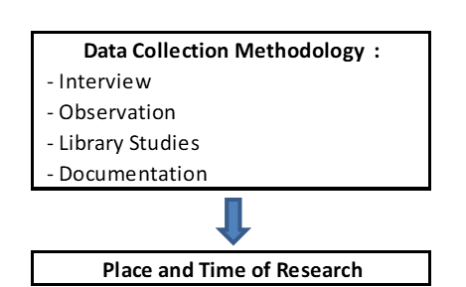

**Figure-2 Research Methods**

1. **Interview**, namely by conducting direct question and answer with the administration staff at the Singkup Village Office. Interviews were conducted after the researchers obtained population data through the website in Singkup Village.

B. **Observation**, namely research conducted by direct observation of the object of research at the Office of the Head of Singkup Village, Kuningan Regency.

C. **Literature Study**, namely the technique of collecting data by searching literature, books, notes, and reports related to research. In this case the writer collects various theories according to the research title, then compares with the results of the data obtained from interviews and observations, so as to find clear data.

D. **Documentation**, namely collecting several documents at the Singkup Village Office in Kuningan Regency in any form in the form of photos or files regarding Population Data.

**Place and Time of Research :**

1. Research Place

The place of implementation of this research is at Office of the Head of Singkup Village, Kuningan Regency, at Address: Jalan Raya Singkup no 16, Kuningan Regency.

1. Time of Research

The research was conducted on January 29 - 31, 2024.

**RESULT AND DISCUSSION**

**Profile of Singkup Village, Pasawahan District - Kuningan Regency**

Administratively, Singkup Village is one of the villages in the Pasawahan sub-district, Kuningan Regency, with its boundaries, namely to the north by Cidahu Village, to the south by Cibuntu Village, to the west by Pasawahan Village, to the east by Paniis Village. The total area is ---- Ha, and is at an altitude of xxx - xxx mdpl with a tropical climate and administratively consists of 3 RWs and 7 RTs which are divided into 2 hamlets consisting of Dusun Mangun Jaya and Mangun Tapa.

(<https://www.desa-singkup-pasawahan.kuningankab.go.id/profil/deskripsi-singkat>).

The distance from the UCIC Cirebon Campus to Singkup Village is about 20 KM. Singkup Village is one of the Lecturer and Student Assisted Villages of the University of Catur Insan Scholar - Cirebon City.

**Village Consultative Council**

Based on Law No. 6 of 2014 concerning Villages, the Village Consultative Body (BPD), is an institution that carries out government functions whose members are representatives of villagers based on regional representation and are determined democratically, as referred to in Article 1 point 4 of the Village Law.

**Singkup Village Vision and Mission**

**Vision :**

1. Realizing the order of people's lives based on religious values and Pancasila values

2. Realizing the Supremacy of Law, equality and human rights for all people

3. Realizing a just and democratic Scope

4. Realizing a responsive, innovative, and constructive society

5. Creating a prosperous Scope

6. Creating a Safe and Peaceful Scope

7. Realizing an economy capable of providing a solid and solid foundation for sustainable development.

**MISSION:**

**“SERVING SINGKUP VILLAGE COMMUNITIES OVERALL FOR THE REALITY OF ADVANCED, HEALTHY AND PROSPEROUS SINGKUP VILLAGES "**

**Analysis of Village Population Data**

In general, data can be interpreted as a collection of information obtained from an observation in the form of numbers, symbols or characteristics that can provide an overview of a situation or problem. Data can also be defined as a collection of information or values obtained from the observation of an object. Therefore good data is data that can be trusted (reliable), timely and covers a broad scope or can provide an overview of a problem as a whole is relevant data.

While population or demography is the study of the dynamics of the human population. Demographics includes the size, structure and distribution of the population, and how the population changes over time due to births, deaths, migration and aging. Population analysis can refer to society as a whole or certain groups based on criteria such as education, citizenship, religion or certain ethnicity.

Thus, population data is all representations of population data in official and unofficial forms issued by population registration bodies (government and non-government), in various forms, including numbers, graphics, pictures and others.

**Analysis of population data in Singkup Village, Pasawahan District - Kuningan Regency**

One of the purposes of this research is to recapitulate population data based on (a) Gender, (b) Education, (c) Type of Occupation, (d) Marital Status, (e) Age. The method used to process population data is the Common Size Method.

The following is a recapitulation of population data in Singkup Village, Pasawahan District - Kuningan Regency, using the Common Size method:

**1. Population data by gender group**

The population of a country or region is a very important asset in the development and progress of a nation. In-depth understanding of the population is a key factor in development planning, social, economic and public health policies. One important aspect in understanding the population is the distribution and characteristics by sex.

Research on the population by sex provides relevant insights into the demographic composition of a region or country. Gender, which includes the differences between men and women, has an important impact on various aspects of life, including health, education, employment, and social roles. An understanding of population differences based on sex can provide valuable information in designing policies that promote gender equality, address gender disparities, and improve the living conditions of society as a whole. This data also helps estimate the need for and demand for public services, such as health care, education, and social programs.

This study aims to analyze the distribution of the population by sex and analyze changes in this pattern over time. The data collected and the results of this research will make important contributions to planning and decision making in various fields, including family planning, development planning, and health policy.

Population composition based on gender is the division of the population based on gender, namely men and women. The following is a table of population based on gender, in Singkup Village, Pasawahan District, Kuningan Regency :

**Table-2 Population data by gender group in Singkup Village - Pasawahan District**



**Description :**

From Table-2 it can be seen that the population is based on gender, where the male population is 954 (52%), and the female population is 894 (48%).

**2. Total population based on education level**

Number of Population by Level of Education is the level of education is one measure of the quality of the population. The higher the level of education completed, the better the quality of human resources in the region. In-depth understanding of the population by education level provides important insights into planning education policy, economic development, and social equity and inclusion.

Research on the population based on educational level allows a comprehensive mapping of the distribution and characteristics of the population in the context of education. The level of education reflects access to and participation in the education system, as well as mastery of knowledge and skills possessed by individuals.

An understanding of population differences by education level provides important information in designing and implementing more inclusive and quality education policies. This data helps identify gaps in access to education, analyze trends in education, and identify vulnerable population groups. This study aims to analyze the distribution of the population based on educational level and analyze changes in this pattern over time. The data collected and the results of this research will make an important contribution to planning and decision making in various fields, including education policy, workforce training, and human resource development.

Table-3 below is the number of residents by education level in Singkup Village, Pasawahan District - Kuningan Regency :

**Table-3 Population based on education level**

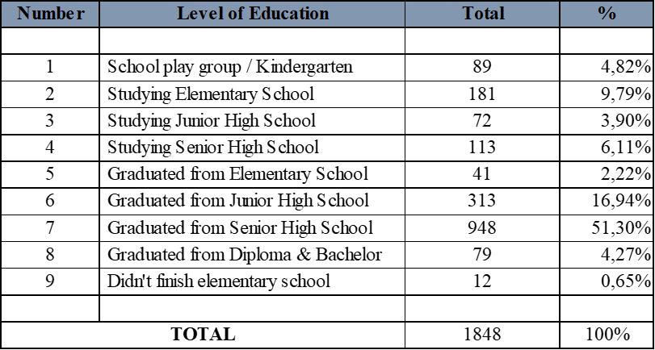

**Description of Table-3:**

Table-3 above is a population based on education level in Singkup Village, Pasawahan District. From these data, it can be seen that the education level of high school graduates (in Singkup Village) ranks first with 948 residents (51.30%).

**3. Total population by occupation**

Work is one of the key aspects in the social and economic life of a society. An in-depth understanding of the population by type of occupation provides important insights into employment analysis, economic development, and social policy and labor market planning. Research on the population by type of occupation enables a comprehensive mapping of the distribution and characteristics of the population in the context of employment and employment. Types of work cover a wide range of sectors, including formal and informal sectors, professional jobs, skilled jobs, and jobs that are prone to poverty or instability.

Understanding population differences by type of work provides important information for designing inclusive employment policies, identifying potential sectors for economic development, and promoting the sustainability and quality of employment. This data also assists in the analysis of social and economic disparities, and helps identify population groups that require special assistance or protection.

Work is an economic activity carried out by a person with the intention of obtaining or helping to obtain income or profit, at least 1 hour (uninterruptedly) in the past week. These activities include patterns of unpaid worker activities that help in a business/economic activity. The following is the composition of the population based on occupation, in Singkup Village, Pasawahan District - Kuningan Regency :

**Table-4 Population based on Occupation**

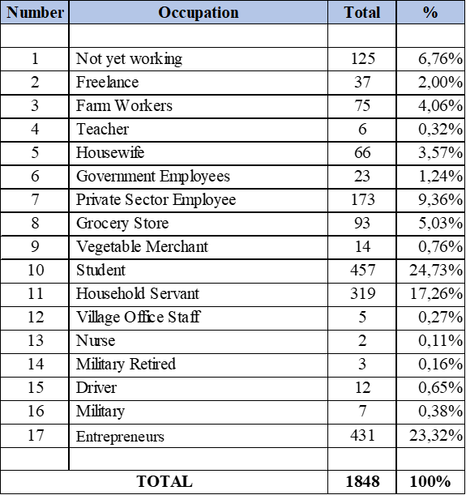

**Description of Table-4:**

From Table-4 above, the highest percentage of the population based on the type of work is students (24.73%) and entrepreneurs (23.32%).

**4. Total population by marital status**

Marital status is an important aspect of the social life and demographics of a society. In-depth understanding of the population by marital status provides relevant insights in the analysis of family relations, social policies and development planning. Research on the population based on marital status enables a comprehensive mapping of the distribution and characteristics of the population in the context of marital life and family relations. Marital status includes various categories, such as single, married, divorced, or widower/widow.

An understanding of population differences based on marital status provides important information in designing family policies, social protection, and women's empowerment programs. This data is also helpful in analyzing demographic trends, understanding changing patterns of marriage, and identifying population groups that require special support or attention. This study aims to analyze the distribution of the population based on marital status and analyze changes in this pattern over time. The data collected and the results of this research will make an important contribution to family policy planning, social protection, and efforts to improve family and community welfare.

Marital status is not only for those who are legally married (traditional, religious, state and so on) but also those who live together and are considered husband and wife by the surrounding community. The following is a table of population in Singkup Village based on marital status:

**Table-5 Population based on Marital Status**

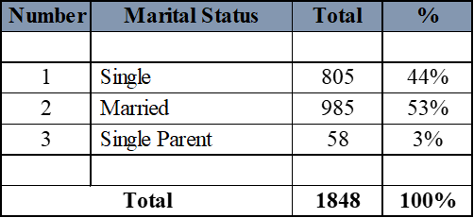

**Description of Table-5:**

Table-5 above is the population data of Singkup Village based on marital status.

**5. Total Population by Age Group**

The age structure of the population is an important factor in understanding the demographics of a country or region. In-depth understanding of the population by age group provides critical insights into development planning, health policy, and social planning. Research on the population by age group allows a comprehensive mapping of the distribution and characteristics of the population in the context of the life cycle. Age groups cover a wide range of ages, such as toddlers, children, teenagers, young adults, adults, and seniors.

Residents are all people who have been domiciled in the geographical area of the Republic of Indonesia for 6 months or more and or those who have been domiciled for less than 6 months but intend to settle down. The definition of age is calculated in years by rounding down or equal to the age at the time of the last birthday.

Population by age group is the population grouped according to the 5 year age group. Number of population according to age group (5 year interval) and sex: Total population in the age group 0-4 years, namely the number of residents before reaching the age of 5 years. This age group is often called toddlers (under five years). The year units for the age of the population are stated by rounding down. For example, someone with an age of 4 years 10 months 25 days is expressed as 4 years old. Likewise for the next age group. Dependency ratio : The ratio between the number of people who are not yet productive (age less than 15 years) and no longer productive (age 65 years and over) with the number of people belonging to productive age (15-64 years) Sex Ratio : Comparison of the number of male population male with the number of female population in a certain area and time.

The following is the population based on 'age group' in Singkup Village, Pasawahan District - Cirebon Regency:

**Table-6 Population data by age group in Singkup Village - Pasawahan District**

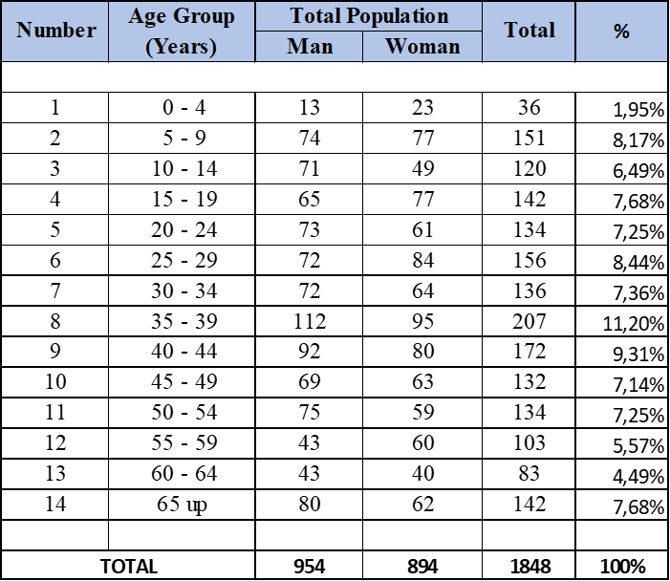

**Description of Table-6 :**

From table-6 above, the highest population composition by age group is at the age of 35-39 with 207 people (11.20%).

**CONCLUSION**

In this study, population analysis was carried out based on gender, education level, type of work, marital status, and age group using the common size method. Following are the conclusions that can be drawn from the results of the analysis:

1. **Population Analysis Based on Gender:**

The distribution of the population by sex shows an almost equal proportion of men and women in the overall population.The sex ratio provides information about the ratio of the number of males and females in the population. The analysis shows that the sex ratio tends to be stable, but can vary in certain age groups or regions.

1. **Population Analysis Based on Education Level:**

The distribution of the population by education level shows different levels of enrollment among age groups. The literacy rate and the level of formal education attained by the population reflect the access to and quality of education in a country or region.

1. **Population Analysis Based on Type of Work:**

The distribution of the population based on the type of work provides an overview of the structure of employment and the economic sector of a society. Analysis of the type of work shows that there are variations in labor force participation across sectors, including the formal and informal sectors, as well as differences in the level of skills required in jobs.

1. **Population Analysis Based on Marital Status:**

The distribution of the population by marital status shows variations in family composition and marital relations within a society. Analysis of marital status helps in understanding family dynamics, divorce rates, and the protection and support needed by certain population groups.

1. **Population Analysis Based on Age Group:**

The distribution of the population by age group provides insight into the composition and dynamics of the population in the life cycle. Age group analysis assists in identifying vulnerable population groups, health and education service needs, and social and economic planning.

Through analysis using the common size method, we can gain a better understanding of the distribution and characteristics of the population based on gender, level of education, type of work, marital status, and age group. These data provide important information in designing policies that are more inclusive, promote equity, and improve the quality of life for society as a whole. However, it should be noted that social, cultural and regional factors also need to be considered in a more in-depth analysis.

**REFERENCES**

Aknesia, A., Effendy, I., Syazili, A., Ulfa, M., Bakti, A. M., & Utami, P. I. (2024). Visualisasi Data Penduduk Desa Sungai Buaya Menggunakan Aplikasi Tableau Public. *Jurnal Pengabdian Masyarakat Bangsa*, *1*(11), 2726–2737.

Hidayatullah, D. N., Amajid, M. N., & Purwanto, E. (2024). Sistem Informasi Pengelolaan Arsip Data Kependudukan Berbasis WEB Di Kantor Kepala Desa Kebonharjo. *Prosiding Seminar Nasional Hukum, Bisnis, Sains Dan Teknologi*, *4*(1).

Maria, S., Simatupang, J., & Manurung, F. (2023). IMPLEMENTASI SISTEM INFORMASI KEPENDUDUKAN PADA DESA SENDAUR BERBASIS WEB. *Jurnal Intra Tech*, *7*(1), 36–44.

Noubiap, J. J., Nansseu, J. R., Lontchi-Yimagou, E., Nkeck, J. R., Nyaga, U. F., Ngouo, A. T., Tounouga, D. N., Tianyi, F.-L., Foka, A. J., & Ndoadoumgue, A. L. (2022). Geographic distribution of metabolic syndrome and its components in the general adult population: A meta-analysis of global data from 28 million individuals. *Diabetes Research and Clinical Practice*, *188*, 109924.

Prasetyana, D. G. R., Astutik, I. R. I., & Eviyanti, A. (2024). Sistem Informasi Kependudukan Web untuk Desa Pasinan Lemahputih, Gresik. *Jurnal Teknoinfo*, *18*(1), 284–295.

Pujiyanto, A., & Alamsyah, N. (2022). Perancangan Sistem Informasi Kependudukan Di Perumahan Citra Swarna Riverside. *Semnas Ristek (Seminar Nasional Riset Dan Inovasi Teknologi)*, *6*(1).

Ramadhan, B. A., & Setyowati, E. (2023). Analisis Pengaruh Populasi Penduduk, Upah Minimum, Pertumbuhan Ekonomi, Dan Indeks Pembangunan Manusia Terhadap Tingkat Partisipasi Angkatan Kerja Provinsi Banten Tahun 2017-2021. *Primanomics: Jurnal Ekonomi & Bisnis*, *21*(3), 82–89.

Riani, N., & Zulkarnain, Z. (2020). Analisis Common Size dan Rasio Keuangan pada Subsektor Wholesale (Durable & Non-Durable Goods) Yang Tercatat di BEI. *Progress: Jurnal Pendidikan, Akuntansi Dan Keuangan*, *3*(2), 155–169.

Rijanandi, T., Wibowo, T. D. C. S., Pratama, I. Y., Adhinata, F. D., & Utami, A. (2022). Web-Based Application with SDLC Waterfall Method on Population Administration and Registration Information System (Case Study: Karangklesem Village, Purwokerto). *Jurnal Teknik Informatika (JUTIF)*, *3*(1), 99–104.

Ritchie, H., & Roser, M. (2023). The world population is changing: For the first time there are more people over 64 than children younger than 5. *Our World in Data*.

Rohman, T., & Effindi, M. A. (2022). Smart Village Dalam Bentuk Sistem Informasi Data Kependudukan (SIDK) Menggunakan Metodologi Extreme Programming. *JIKO (Jurnal Informatika Dan Komputer)*, *5*(2), 142–149.

Sinaga, W. I. S., Buaton, R., & Sembiring, H. (2023). Klasifikasi Data Penduduk Pada Pemilihan Umum Di Kota Binjai Menggunakan Algoritma K-Means (Studi Kasus: KPU Kota Binjai). *Explorer*, *3*(2), 95–102.

Sitorus, Z., & Suhartika, S. (2024). PENERAPAN DATA MINING UNTUK CLUSTERING PENDUDUK MISKIN DI KOTA TANJUNGBALAI MENGGUNAKAN METODE ALGORITMA K-MEANS. *JOURNAL OF SCIENCE AND SOCIAL RESEARCH*, *7*(1), 212–218.

Suriani, N., & Jailani, M. S. (2023). Konsep Populasi dan Sampling Serta Pemilihan Partisipan Ditinjau Dari Penelitian Ilmiah Pendidikan. *IHSAN: Jurnal Pendidikan Islam*, *1*(2), 24–36.

Suwandi, S., Dewi, W. N., & Septian, W. E. (2021). DESIGN APPLICATION OF REVENUE HOTEL MANAGEMENT USING COMMON SIZE METHOD. *Global Conference on Business and Management Proceedings*, *1*(1), 73–83.

Tricahyono, D., & Wijaya, S. (2023). Pengaruh Kontribusi Sektor Agrikultur Dan Sektor Industri Dalam PDB Terhadap Penerimaan Pajak Di ASEAN Dengan Variabel Populasi Penduduk Urban Sebagai Moderasi. *Akuntansiku*, *2*(3), 120–132.

Weissbrod, O., Kanai, M., Shi, H., Gazal, S., Peyrot, W. J., Khera, A. V, Okada, Y., Martin, A. R., & Finucane, H. K. (2022). Leveraging fine-mapping and multipopulation training data to improve cross-population polygenic risk scores. *Nature Genetics*, *54*(4), 450–458.