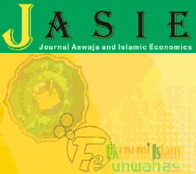JASIE *-* Journal of Aswaja and Islamic Economics *Vol. 01 No. 02 - 2022*

*Website Journal : https://*[*www.publikasiilmiah.unwahas.ac.id/index.php/JASIE/index*](http://www.publikasiilmiah.unwahas.ac.id/index.php/JASIE/index) *DOI* : [10.3194/jse.v1i1.6877](https://publikasiilmiah.unwahas.ac.id/index.php/JASIE/)

ISSN : [2962-5602](https://publikasiilmiah.unwahas.ac.id/index.php/JASIE/index) (Online) ISSN : [2963-7864](https://publikasiilmiah.unwahas.ac.id/index.php/JASIE/index) (Print)

FACTOR ANALYSIS OF THE UNDERUTILIZATION OF ISLAMIC PENSION FUNDS IN INDONESIA

**M. Luthfi Al Abshor1, Haris Nur Ihsan2 , M. Rizqi Virgiawan Pradana3, Rinda Asytuti4**

1UIN K.H. Abdurrahman Wahid Pekalongan Jl. Pahlawan No. 52,

Rowolaku, Kab. Pekalongan,

Indonesia[muhammad.luthfi.al.abshor@mhs.uingusdur.ac.id.](mailto:muhammad.luthfi.al.abshor@mhs.uingusdur.ac.id.)

2UIN K.H. Abdurrahman Wahid Pekalongan Jl. Pahlawan No. 52,

Rowolaku, Kab. Pekalongan,

Indonesia [haris.nur.ihsan@mhs.uingusdur.ac.id](mailto:haris.nur.ihsan@mhs.uingusdur.ac.id)

3UIN K.H. Abdurrahman Wahid Pekalongan Jl. Pahlawan No. 52,

Rowolaku, Kab. Pekalongan,

Indonesia [muhammad.rizqi.virgiawan.pradana@mhs.uingusdur.ac.id](mailto:muhammad.rizqi.virgiawan.pradana@mhs.uingusdur.ac.ids)

4UIN K.H. Abdurrahman Wahid Pekalongan Jl. Pahlawan No. 52,

Rowolaku, Kab. Pekalongan,

Indonesia [rindanadirin@gmail.com](mailto:rindanadirin@gmail.com)

***ABSTRACT***

*Pension funds are one of the funding system options used to collect funds. It is the means needed to ensure that participants' income remains when they grow old. Law Number 11 of 1992 provides the foundation for pensions in Indonesia, involving Financial Institution Pension Funds (DPLK) and Occupational Pension Funds (DPPK). The purpose of this research is to find out what are the factors for the lack of use of Islamic pension funds in Indonesia. This research uses a qualitative and deductive approach to analyze the management of Islamic pension funds. The results of this study show that Islamic pension funds face challenges, including a lack of supportive regulations, a lack of public awareness, and limited Islamic investment products. Despite the huge growth potential, Islamic pension funds have yet to reach their peak. The government needs to take special measures, including the creation of supportive legislation, as well as raising the credibility of Islamic pension funds. Through increased transparency, strong governance and public education, Islamic pension funds can play an important role in strengthening Islamic finance in Indonesia. These results provide a deeper understanding of the underutilization of Islamic pension funds in Indonesia.*

**Keywords** : *Sharia Pension Fund, Transparency, Special Acts.*

# INTRODUCTION

Since the establishment of the regulation of Law No. 11 of 1992, pensions are available to all workers, both in private institutions and self-employment, as well as to civil servants and the Armed Forces. This law stipulates the establishment of the Financial Institution Pension Fund (DPLK) and the Occupational Pension Fund (DPPK).

Under Law No. 11 of 1992, a pension fund is defined as "a legal entity that manages and operates a program that promises retirement benefits." Therefore, it is clear that institutions that have legal entities such as commercial banks or life insurance are the ones that manage pension funds. According to the above understanding, a pension fund is one of the funding system options used to collect funds. It is the means needed to ensure that participants' income remains when they grow old.

One of the best ways to prepare yourself for an income when you are old is to join a retirement program. Workers have pension plans that offer insurance in case they cannot work anymore due to their older age. Pension plans also offer periodic payments during their retirement. Pension security includes social security such as pension insurance, which aims to guarantee that beneficiaries and their heirs live well after they reach retirement age, suffer permanent total disability, or die. (Iit Novita Riyanti, 2021)

It is important to manage pension funds, including how to use them under Indonesian sharia law. Although the concept of Islamic pension funds has been introduced, a factor analysis needs to be conducted to find out why its application is still less effective. Nonetheless, the facts show that the acceptance and utilization of Islamic pension funds are still not reaching their potential. This is due to the fact that Islamic pension funds are in accordance with Islamic sharia principles, which emphasize fairness and avoid elements of usury and speculation. Some of the reasons why sharia pension funds still exist are due to factors such as regulation, public understanding, and the availability of sharia-compliant investment products. As a result, before creating a strategy to increase the use of Islamic pension funds in Indonesia, it is imperative to conduct a thorough analysis of these elements.

# RESEARCH METHOD

This research was conducted using a qualitative approach. Methodologically, this approach uses deductive thinking, which means that a series of variables and research results are proven through cause and effect thinking (Somantri, 2005). The type of research he conducted was a literature study, in which the author collected information by reading journals and books, then conducted in-depth analysis to gain an in-depth understanding of how to manage pension funds based on sharia principles, now known as Sharia Pension Funds.

# RESULT AND DISCUSSION

In 2022, there were 11 Pension Funds that were dissolved. These consist of 4 DPPKPPMP: Pension Fund of Universitas Merdeka Malang, HKBP Pension Fund, Infomedia Nusantara Pension Fund, and Bakrie Pension Fund; and 7 DPPKPPIP: PT Persero Batam Employee Pension Fund, Apac Inti Corpora Pension Fund, Harapan Sejahtera Pension Fund, Al Ihsan Hospital Pension Fund, Swadharma Indotama Finance Pension Fund, Perum Perumnas Pension Fund, and Artha Graha Pension Fund. Thus, the total number of Pension Funds will be 201, consisting of 175 DPPK and 26 DPLK, by the end of 2022

**Table 01.** Number of Combined Pension Funds in 2018 to 2022

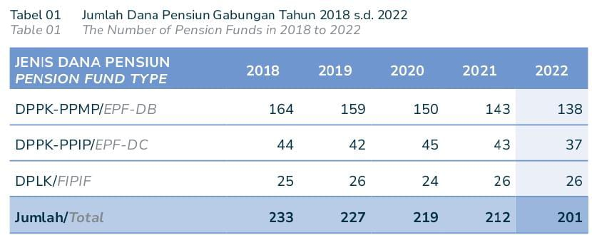

The above pension fund types show that DPPK PPMP still dominates the industry. However, compared to the previous year, the number of DPPK PPMP and DPPK PPIP decreased from 143 pension funds to 138 and from 43 pension funds to 37. In contrast, DPLK remained the same, from 26 pension funds to 26 pension funds. The number of pension funds decreased in 2021 because the founders closed them down. Founders dissolve their pension funds to improve their operational and financial efficiency. In addition, there is another reason for dissolving the pension fund, namely the existence of a mandatory Pension Guarantee (JP) program managed by BPJS Ketenagakerjaan.

**Table 02**. Growth in the number of pension funds from 2018 to 2022

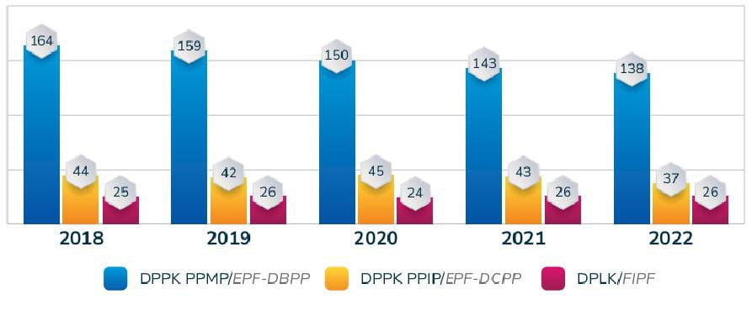

As the Founder closed it down, the number of Pension Funds decreased in 2022. To improve its operational and financial efficiency, the Founder dissolved its Pension Fund, which was a mandatory Pension Benefit (JP) program managed by BPJS Ketenagakerjaan. DPLK then received the funds from the dissolved Pension Fund.

Indonesia should play an important role in upholding and strengthening Islamic finance because it is the largest Muslim country. When the economy in Indonesia is rising or falling, people usually allocate their investments with the aim of encouraging the efficiency of economic growth. This is how Islamic finance will help strengthen the country's economy. (Febriani, 2014). Compared to other Islamic financial sectors, Islamic pension funds are still very low. However, the regulation on Islamic pension funds, issued by the Financial Services Authority with Number 33/POJK.05/2016, regulates the implementation of pension fund programs based on sharia principles. Where government and company employees will benefit from this program as they can get a pension fund that can help them survive when they are old.

Until now, the Financial Services Authority (OJK) has not yet transacted the running sharia pension funds. There are reasons for this. First, the government has not made strong regulations or strategies to support Islamic pension funds. Secondly, there are few places for pension funds to invest. Lastly, the public is not sufficiently educated about the necessity of knowing what an Islamic pension fund is.

The implementers of Islamic DPLK have also requested the government for the inclusion of such regulations in the pension law. this will make it possible to develop a very large range of investment instruments according to its characteristics. Due to the limitations of its tools, the bulk of the Islamic pension fund portfolio consists of deposits and Islamic investments, along with other elements. With the majority of the population being Muslim and a large market share, the future prospects for pension funds look bright. The government recognizes the need to adopt three strategies for the development of Islamic pensions, including accelerating formalization, improving risk oversight over time, and establishing an early warning reporting and monitoring system.

Sharia-based pension funds have enormous potential to support the growth of Sharia finance in Indonesia, and this can be explained by several factors:

a) Public participation in pension programs is still limited, especially among civil servants. In contrast, many employees in the private and self-employed sectors could be targeted by Sharia pension programs.

b) The development of Sharia financial institutions and industries affects the human resources of Sharia pension funds.

c) Public awareness of Sharia financial institutions is increasing, bringing a positive reputation and a growing following, particularly in the context of Sharia pensions.

However, it is important to remember that the development of Sharia pension funds is not as fast as other financial sectors. In some instances, the lack of strategic and regulatory support can lead to various things (Putri, 2011):, namely:

1. The Pension Fund Industry Development Policy and Strategy 2007-2011 does not discuss Islamic pension funds when Islamic capital markets, banking, and insurance already have and incorporate their own development strategies.

2. In terms of laws, the regulations as the operational framework of Islamic pension funds only refer to general regulations and fatwas of DSN-MUI, not specific ones. This is because Islamic banking, insurance, mutual funds and bonds do not yet have regulations and support from DSN-MUI fatwas.

3. So far, Islamic DPLKs have complained about the huge tied investment product (mudharabah muqayyadah). Due to the direct investment provisions in Law No 11/1992 on pension funds, Islamic DPLK cannot be included. Because the mudharabah muqayyadah product is an investment in infrastructure or property. However, the maximum credit limit prevents Islamic banks from financing such projects. However, if an Islamic pension fund is included, you may receive a return of up to twenty to thirty percent of your investment.

Therefore, to help the growth of Islamic pension funds in Indonesia, the government created several laws specifically for Islamic pension funds. Some of these are:

a. National Sharia Council Rules

Fatwa of the National Sharia Council (DSN) Number 88/DSN-MUI/XI/2013 concerning general guidelines for organizing pension programs based on sharia principles. This fatwa regulates the management of pension funds in sharia.

b. Financial Services Authority Rules

OJK Regulation No.33/POJK.05/2016 regulates pension programs based on sharia principles in addition to the DSN. According to this regulation, the manager must have a DPS. This DPS is responsible for ensuring that activities related to the program and pension do not violate sharia principles. According to OJK's 2020 report, there are four sharia pension funds in Indonesia: Muamalat Financial Institution Pension Fund, Muhammadiyah Workers Pension Fund, Jakarta Islamic Hospital Workers Pension Fund, and Muhammadiyah Surakarta University Workers Pension Fund.

The governance of Islamic pension funds must be established to encourage their growth. Several things must be done for pension funds to operate well and be more competitive:

a. Enhancing the function of the Sharia Supervisory Board. This board is responsible for overseeing and ensuring that programs are run in accordance with sharia principles, as well as providing assurance to stakeholders on the implementation of sharia. In addition, the human resources of the sharia supervisory board should be improved.

b. In addition, there must be a strong internal control system and risk management system. This is very important to avoid mistakes that occur during the development process, such as product failure. Therefore, everything must be thoroughly planned and viewed.

c. It is imperative for Islamic pension fund participants to be more transparent about how their funds are managed. This is because transparency will give participants a feeling of security and trust, which in turn will increase their confidence in Islamic pension funds..

# CONCLUSION

Islamic pension funds are Islamic financial institutions that have features that allow a person to maintain their income after they stop working productively. Where this institution helps people to make them better off when they are old. The Qur'an also teaches its people not to leave behind weak descendants and to prepare for a better tomorrow. Basically, pension fund management must be done in a sharia-compliant manner. There needs to be regulations and strategies that support the growth of Islamic pension funds in a more competitive market.

In 2022, a total of 11 Pension Funds were closed, with the majority coming from DPPKPPMP and DPPKPPIP. Although the total number of Pension Funds at the end of the year reached 201, consisting of 175 DPPKs and 26 DPLKs, there was a decrease in the number of DPPKPPMP and DPPKPPIP compared to the previous year. This decline was partly due to the closure of Pension Funds in 2021, either due to founder's decision or in response to the Pension Guarantee (JP) program required by BPJS Ketenagakerjaan. Although pension fund management faces challenges, especially in the sharia context, with the lack of supporting regulations, low public awareness, and limited sharia investment products. The government has a crucial role in the development of Islamic pension funds in Indonesia. Although regulations have been issued by the Financial Services Authority, implementation is still hampered by the lack of strong strategic and regulatory support. Sharia DPLK implementers urge the government to include these regulations in the pension law, opening up opportunities for greater development of sharia investment instruments.

Although there are still obstacles, Islamic pension funds have great potential for growth. Factors such as limited community participation, the development of Islamic financial institutions, and increasing awareness about Islamic finance could catalyze growth. However, further action is needed to improve transparency, strong governance and public education to support the development and effective use of Islamic pension funds in Indonesia.

# REFERENCES

Iit Novita Riyanti, H. H. A. (2021). Optimizing the Role of Singajaya Village-Owned Enterprises (Bumdes) in Improving Community Welfare (Case Study in Bodas Village, Watukumpul District). Journal of Al-Idārah, 2(1), 80-93.

Putri, R. I. (2011). Pension Funds in the Perspective of Sharia Business Law. Al-'Adalah, 10(1), 99-108. [Www.Pembelajar.Com/](http://Www.Pembelajar.Com/)

Febriani, S. (2014). Analysis of Investment in Mutual Fund Instruments in Pension Funds, 8(1), 1-8.

Norman, E., & Pahlawati, E. (2021). Sharia Pension Fund Management. Reslaj: Religion Education Social Laa Roiba Journal, 3(2), 226-235.