**Interface Structure in Friction Welded Joints between Stainless Steel 304 and Mild Carbon Steel**

**Helmy Purwanto**

Department of Mechanical Engineering, Faculty of Engineering,  
Universitas Wahid Hasyim, Jl. Menoreh Tengah X/22 Sampangan, Semarang – Indonesia

*Corresponding author:* [*helmypurwanto@unwahas.ac.id*](mailto:helmypurwanto@unwahas.ac.id)

##### Abstract

##### Friction welding is a solid-state welding process using heat generated through friction. Dissimilar materials can be joined properly with friction welding. This study is a continuation of the previous study and aimed to determine the interface structure occurred on stainless steel and carbon steel joints. Stainless steel 304 and mild carbon steel are joined with this method at 2000 rpm rotation for 15 seconds and forging time of 5 seconds with a pressure of 5 MPa. The results of a micro-observation using a scanning electron microscope show good bonding in the interface area. The carbon steel is more welded to the stainless steel in the periphery than in the center. The spectrum results of Energy Dispersive X-Ray of the interface show Fe, C and Cr elements content. This is what causes the strong welding bond.

##### Keywords: dissimilar welding, friction welding, interface, welding mix

**INTRODUCTION**

A machine construction using steel requires welding. Steel joints may use permanent or non-permanent joints. Permanent joints include welding joints. One of the common welding processes is friction welding. Friction welding is a solid-state welding process using heat generated through friction and added with pressure. Heat is generated from the conversion of mechanical energy into thermal energy and visco-plastic deformation acting on the work piece interface during rotation under pressure or friction of two material surfaces by rotating or reciprocating motion (Meshram, Mohandas and Reddy, 2007)(Li *et al.*, 2016). Friction welding is considered a forging technique, because the welding is done by applying pressure after the surfaces are subjected to friction (Akhil and Charles, 2017). Pressure and friction generate heat at the interface, thereby forming on the frictional surface an intermetallic layer on copper and AISI 430 ferritic stainless-steel material (Shanjeevi, Arputhabalan and Dutta, 2017).

Friction welding is advantageous when it comes to joining two different materials (dissimilar welding) and without filters. With friction welding, high production rate can be achieved and hence economical in operation. Joints of a combination of dissimilar metals are used in construction that requires a combination of special properties and to save costs on expensive and rare materials. During fusion welding of stainless-steel, negative metallurgical changes occur, such as: formation of delta ferrite and deposition of chromium carbide between grain boundaries. These metallurgical changes can be eliminated with friction welding (Özdemir, 2005; Yoon *et al.*, 2006; Sahin, 2007). Welding of stainless-steel also induces the formation of ferrite deltas, sigma phases, stress corrosion cracking, and sensitization at the interface. Friction welding method is able to overcome economically for similar or dissimilar metal combinations (Nicholas, Jessop and Dindsdale, 1978). In the joint area an interface bond occurs and forms an intermetallic phase Al12Mg17 in aluminium alloys welded with Magnesium alloys (Mofid and Loryaei, 2019). The formation of intermetallic compounds is affected by the amount of frictional heat which in turn can affect the mechanical properties of the joint (Mehta, 2019).

Carbon steel and stainless steel can be welded using fusion welding, though several studies recommend solid-state welding to achieve better connection in dissimilar welding (Mehta and Badheka, 2016; Beygi *et al.*, 2021; Gotawala and Shrivastava, 2021; Mehta *et al.*, 2021). Frictional welding in copper and stainless steel is capable of producing superior interatomic diffusion leading to an increase in the metallurgical bonding of the joint (Vyas *et al.*, 2022). A bond interface occurs in the welding of carbon pipe and alloy steel using friction welding with quenching-tempering treatment, resulting in better joint strength (Seshu Kumar *et al.*, 2021) .

Engineering to improve the quality of friction welding on dissimilar materials has been carried out. Among them by adding materials to the joint. Nickel interlayers produce different joint structures and strengths. The addition of nickel material to the interlayer SS 304 and AISI 1040 can increase the tensile strength and decrease the hardness due to reduced chromium deposits in the interlayer (James and Sudhish, 2016).

Purwanto et al (Purwanto, Tauviqirrahman and Dzulfikar, 2021) had conducted a Continuous Drive Friction Welding (CFDW) study using a friction welding tool with 2000 rpm rotation on 304 stainless steel material, with mild carbon steel applying the pressure. Friction was done for 15 seconds and forging for 5 seconds. While the pressure was alternated between 3 MPa, 4 MPa and 5 MPa. The results showed that SS304 and mild carbon steel can be joined by friction welding and the tensile strength of the joint is greater than the strength of the carbon steel base metal.

Friction time, frictional pressure, forging time, forging pressure and rotation speed are main welding variables in the friction welding method. Friction welding has been performed on carbon steel and stainless steel with pressure variations of 3 MPa, 4 MPa and 5 MPa. The tensile test results show a greater tensile strength of the joint than the strength of the base metal carbon steel and break occurred in the carbon steel base metal (Purwanto, Tauviqirrahman and Dzulfikar, 2021). In this study, a test was conducted to determine the interface structure occurring in the joint. A micro-analysis was conducted in the joint area and showed why the tensile strength of friction welding joint is greater compared to base metal carbon steel.

**EXPERIMENTAL SECTION**

This study is a continuation of the previous study (Purwanto, Tauviqirrahman and Dzulfikar, 2021) to determine the bond occurring at the interface. Carbon steel and stainless steel with a length of 100 mm each with a cylindrical shape with a diameter of 10 mm were welded by the Continuous Drive Friction Welding (CFDW) method. The friction time was 15 seconds at 2000 rpm and forging time of 5 second with a pressure 5 MPa. The analysis was carried out using a Scanning Electron Microscope-Energy Dispersive X-Ray (SEM-EDX) Phenom ProX© Thermo Scientific gen 6. The chemical composition of stainless steel 304 and mild carbon steel used is presented in Table 1.

**Table 1.** Chemical composition of stainless steel 304 and carbon steel

|  |  |  |  |  |  |  |  |  |  |  |  |
| --- | --- | --- | --- | --- | --- | --- | --- | --- | --- | --- | --- |
| **Material** | **Chemical composition % (weight)** | | | | | | | | | | |
| **C** | **Si** | **Mn** | **Ni** | **Cr** | **Cu** | **Mo** | **N** | **S** | **P** | **Fe** |
| **Stainless stell 304** | 0.05 | 0.29 | 0.94 | 8.23 | 18.47 | 0.15 | 0.07 | 0.03 | - | 0.04 | 71.33 |
| **Mild Carbon steel** | 0.05 | 0.12 | 0.28 | - | 0.31 | 0.01 | - | 0.02 | 0.02 | 0.02 | 99.10 |

**RESULTS AND DISCUSSION**

The joint results with the friction welding method with a friction time of 15 seconds at 2000 rpm and a forging time of 5 seconds with a pressure of 5 MPa are shown in Figure 1.

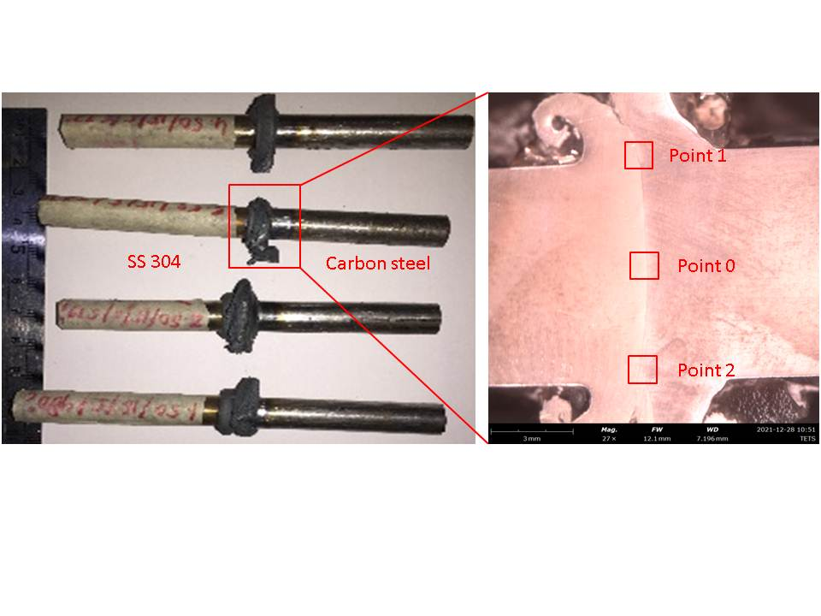

|  |  |
| --- | --- |
| (a) | (b) |

**Figure 1:** Friction welding results a). joint and b). cross-section of the joint

All samples were joined with over flow since both ends of the samples were rubbed into a solid state due to pressure and forging (Figure 1a). We can see the joint boundary between the stainless steel 304 and mild carbon steel. The interface is obvious as if both metals are not properly joined, but the tensile test shows a greater tensile strength of the joint than the tensile strength of the carbon steel base metal. From the tensile test results of all variables, all samples experience break in the carbon steel base metal (Purwanto, Tauviqirrahman and Dzulfikar, 2021). The interface structure of the joint at the midpoint (point 0) is shown in Figure 2.

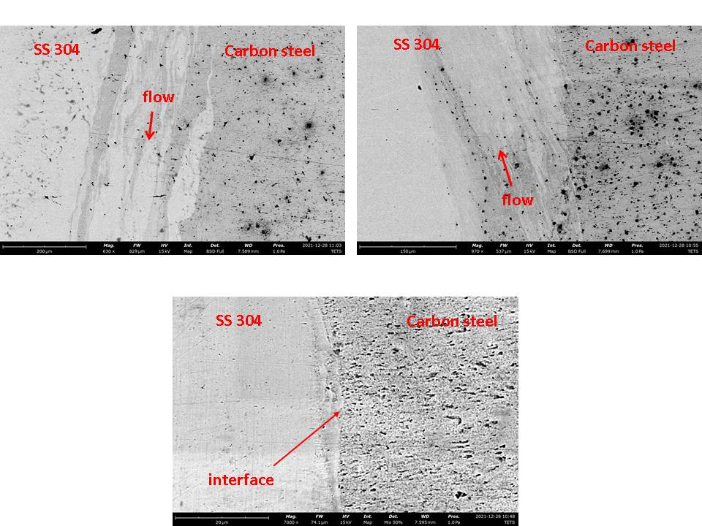

**Figure 2:** Micro-photos of the interface at the midpoint area (point 0)

The boundary between the stainless steel and carbon steel is still visible. The stainless steel appears brighter while the carbon steel is darker. At the interface boundary, carbon steel is seen mixed with stainless steel or vice versa. This results in a stronger, interlocking joint. The elements found in the stainless steel and carbon steel are mixed into one unit.

The interface structure of the joint at the periphery (point 1 and 2) as shown in Figure 3.



|  |  |
| --- | --- |
| (a) | (b) |

**Figure 3:** Micro-photos of the interface at the periphery a). point 1 and b). point 2

In the interface structure at the periphery, greater mixing is observed. The carbon steel is mixed into the stainless more than the midpoint. We can see part of the carbon steel that goes into the stainless steel area or vice versa. This is due to the centrifugal force due to rotation, so the welding bond between stainless steel and carbon steel is strong.

This strong bond is also corroborated by the spectrum results of Energy Dispersive X-Ray (EDX). The EDX spectrum results of the stainless steel base metal, interface and carbon steel base metal are shown in Figure 4.

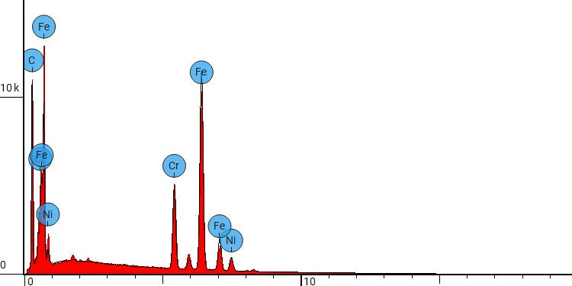 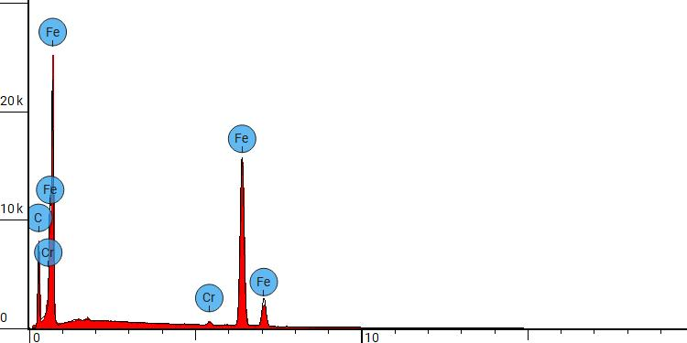 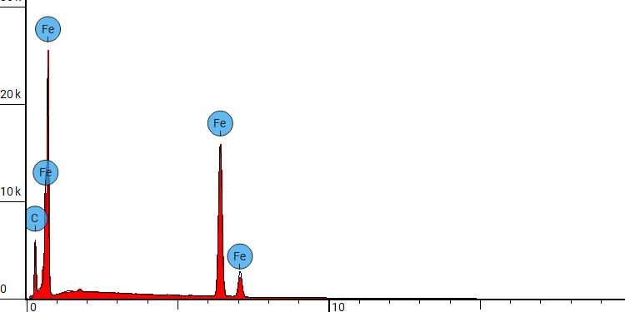

|  |  |  |
| --- | --- | --- |
| (a) | (b) | (c) |

**Figure 4:** EDX spectrum results of (a). stainless steel base metal, (b). interface and (c). carbon steel base metal

The results of the EDX spectrum show the dominant elemental content of the stainless steel base metal, namely Fe, C, Cr and Ni. While the dominant elemental content in the carbon steel base metal is Fe and C. Furthermore, the dominant elemental content in the interface or joint area is Fe, C and Cr. This further proves that in the interface area or the joint area there is a mixture of stainless steel and carbon steel. There is migration of Cr from stainless steel to carbon steel and vice versa. It was also reported by Chander et.al (Chander, Reddy and Tagore, 2013) that there was migration of Cr and Ni from stainless AISI 304 to AISI 4140 steel in the welding zone. Therefore, there is a strong bond interface between the welded metals, as Kumar et.al (Seshu Kumar *et al.*, 2021), stated that this bond interface is caused by the presence of axial and radial flows during the rotation process.

**CONCLUSION**

From this study of the interface structure in friction welded joints between stainless steel 304 and mild carbon steel, concluded are the following:

1. At the interface boundary, carbon steel is seen mixed with stainless steel or vice versa. This results in a stronger, interlocking joint.
2. The results of the EDX spectrum show the dominant elemental content of the stainless steel base metal, namely Fe, C, Cr and Ni. While the dominant elemental content in the carbon steel base metal is Fe and C. Furthermore, the dominant elemental content in the interface or joint area is Fe, C and Cr. This further proves that in the interface area or the joint area there is a mixture of stainless steel and carbon steel.

**REFERENCES**

Akhil, V. and Charles, M. M. M. (2017) ‘An Investigation of Mechanical And Metallurgical Properties of Friction Welded Steel Joint’, 2(5), p. 7.

Beygi, R. *et al.* (2021) ‘A comprehensive analysis of a pseudo-brittle fracture at the interface of intermetallic of η and steel in aluminum/steel joints made by FSW: Microstructure and fracture behavior’, *Materials Science and Engineering: A*, 824, p. 141812. doi: https://doi.org/10.1016/j.msea.2021.141812.

Chander, G. S., Reddy, G. M. and Tagore, G. R. N. (2013) ‘Influence of process parameters on impact toughness and hardness of dissimilar AISI 4140 and AISI 304 continuous drive friction welds’, *The International Journal of Advanced Manufacturing Technology*, 64(9), pp. 1445–1457. doi: 10.1007/s00170-012-4114-3.

Gotawala, N. and Shrivastava, A. (2021) ‘Investigation of interface microstructure and mechanical properties of rotatory friction welded dissimilar aluminum-steel joints’, *Materials Science and Engineering: A*, 825, p. 141900. doi: https://doi.org/10.1016/j.msea.2021.141900.

James, J. A. and Sudhish, R. (2016) ‘Study on Effect of Interlayer in Friction Welding for Dissimilar Steels: SS 304 and AISI 1040’, *Procedia Technology*, 25, pp. 1191–1198. doi: 10.1016/j.protcy.2016.08.238.

Li, W. *et al.* (2016) ‘Linear and rotary friction welding review’, *International Materials Reviews*.

Mehta, K. *et al.* (2021) ‘Investigation of exit-hole repairing on dissimilar aluminum-copper friction stir welded joints’, *Journal of Materials Research and Technology*, 13, pp. 2180–2193. doi: https://doi.org/10.1016/j.jmrt.2021.06.019.

Mehta, K. P. (2019) ‘A review on friction-based joining of dissimilar aluminum–steel joints’, *Journal of Materials Research*, 34(1), pp. 78–96. doi: 10.1557/jmr.2018.332.

Mehta, K. P. and Badheka, V. J. (2016) ‘Effects of Tilt Angle on the Properties of Dissimilar Friction Stir Welding Copper to Aluminum’, *Materials and Manufacturing Processes*. Taylor & Francis, 31(3), pp. 255–263. doi: 10.1080/10426914.2014.994754.

Meshram, S. D., Mohandas, T. and Reddy, G. M. (2007) ‘Friction welding of dissimilar pure metals’, *Journal of Materials Processing Technology*, 184(1–3), pp. 330–337. doi: 10.1016/j.jmatprotec.2006.11.123.

Mofid, M. A. and Loryaei, E. (2019) ‘Investigating microstructural evolution at the interface of friction stir weld and diffusion bond of Al and Mg alloys’, *Journal of Materials Research and Technology*, 8(5), pp. 3872–3877. doi: https://doi.org/10.1016/j.jmrt.2019.06.049.

Nicholas, E. D., Jessop, T. J. and Dindsdale, W. O. (1978) ‘Friction welding of dissimilar metals, advances in welding processes.’, in *Proceeding of 4th International Conference, New York 23*.

Özdemir, N. (2005) ‘Investigation of the mechanical properties of friction-welded joints between AISI 304L and AISI 4340 steel as a function rotational speed’, *Materials Letters*, 59(19), pp. 2504–2509. doi: https://doi.org/10.1016/j.matlet.2005.03.034.

Purwanto, H., Tauviqirrahman, M. and Dzulfikar, M. (2021) ‘The Effect of Deep Cryogenic on Tensile Strength and Impact Toughness in Quench Tempered Steel Plate as A Candidate for Ballistic Resistance Material’, *MM Science Journal*, Desember, pp. 5467–5474. doi: 10.17973/MMSJ.2021_12_2021119.

Sahin, M. (2007) ‘Evaluation of the joint-interface properties of austenitic-stainless steels (AISI 304) joined by friction welding’, *Materials & Design*, 28(7), pp. 2244–2250. doi: https://doi.org/10.1016/j.matdes.2006.05.031.

Seshu Kumar, A. *et al.* (2021) ‘Evaluation of bond interface characteristics of rotary friction welded carbon steel to low alloy steel pipe joints’, *Materials Science and Engineering: A*, 824, p. 141844. doi: https://doi.org/10.1016/j.msea.2021.141844.

Shanjeevi, C., Arputhabalan, J. J. and Dutta, R. (2017) ‘Investigation on the Effect of Friction Welding Parameters on Impact Strength in Dissimilar Joints’, *IOP Conference Series: Materials Science and Engineering*, 197, p. 12069. doi: 10.1088/1757-899X/197/1/012069.

Vyas, H. D. *et al.* (2022) ‘Microstructure evolution and mechanical properties of continuous drive friction welded dissimilar copper-stainless steel pipe joints’, *Materials Science and Engineering: A*, 832, p. 142444. doi: https://doi.org/10.1016/j.msea.2021.142444.

Yoon, H.-K. *et al.* (2006) ‘Mechanical properties of friction welds of RAFs (JLF-1) to SUS304 steels as measured by the acoustic emission technique’, *Fusion Engineering and Design*, 81(8), pp. 945–950. doi: https://doi.org/10.1016/j.fusengdes.2005.09.020.